**GANPAT UNIVERSITY**

**U V PATEL COLLEGE OF ENGINEERING & TECHNOLOGY**

**DEPARTMENT OF COMPUTER SCIENCE AND ENGINEERING**

**B.TECH 1st SEMESTER SUBJECT**

**Name:zeel modi Stream:CBA**

**ASSIGNMENT-1 Date:27/8/14**

GOAL:

1. Write a program to print ASCII values of all backslash characters and white space on screen in following format :

The ASCII value of ‘\t’ is : 9

(Hint : you can verify your ASCII values with the help of a table for ASCII values from text book)

2. Explain different data types available in C.

3. Explain about C Tokens in brief.

4. Explain about backslash characters in C.

**ANSWERS**

**1.** #include<stdio.h>

#include<conio.h>

void main()

{

char a,b,c,d,e,f,g,h,i,j,k,l,m;

a='\a';

b='\b';

c='\f';

d='\n';

e='\r';

f='\t';

g='\v';

h='\\';

i='\'';

j='\"';

k='\?';

l='\N';

m='\XN';

clrscr();

printf("\nThe ASCII value of \\a is :%d",a);

printf("\nThe ASCIIvalue of \\b is :%d",b);

printf("\nThe ASCII value of \\f is :%d",c);

printf("\nThe ASCII value of \\n is :%d",d);

printf("\nThe ASCII value of \\r is :%d",e);

printf("\nThe ASCII value of \\t is :%d",f);

printf("\nThe ASCII value of \\v is :%d",g);

printf("\nThe ASCII value of \\\ is :%d",h);

printf("\nThe ASCII value of \\' is :%d",i);

printf("\nThe ASCII value of \\\" is :%d",j);

printf("\nThe ASCII value of \\\? is :%d",k);

printf("\nThe ASCII value of \\N is :%d",l);

printf("\nThe ASCII value of \\XN is :%d",m);

getch();

}

**getch();**

**}**

**OUTPUT**

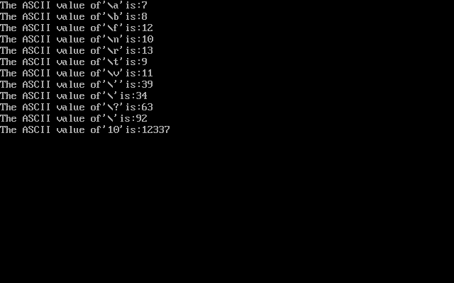

**2.**

**A program usually contains different types of data types (integer, float, character**

**etc.) and need to store the values being used in the program. C language is rich of data types. A C**

**programmer has to employ proper data type as per his requirements.**

**C has different data types for different types of data and can be broadly classified as:**

**1. Primary Data Types**

**2. Secondary Data Types**

**Primary or Fundamentals data type:**

**Integer Data Types:**

**Integers are whole numbers with a range of values, range of values are machine dependent.**

**Generally an integer occupies 2 bytes memory space and its value range limited to -32768 to +32767**

**(that is, -215 to +215-1). A signed integer use one bit for storing sign and rest 15 bits for number.**

**To control the range of numbers and storage space, C has three classes of integer storage namely**

**short int, int and long int. All three data types have signed and unsigned forms. A short**

**int requires half the amount of storage than normal integer. Unlike signed integer, unsigned**

**integers are always positive and use all the bits for the magnitude of the number. Therefore, the**

**range of an unsigned integer will be from 0 to 65535. The long integers are used to declare a longer**

**range of values and it occupies 4 bytes of storage space.**

**Floating Point Data Types:**

**The float data type is used to store fractional numbers (real numbers) with 6 digits of precision.**

**Floating point numbers are denoted by the keyword float. When the accuracy of the floating point**

**number is insufficient, we can use the double to define the number. The double is same as float**

**Character Data Type:**

**Character type variable can hold a single character and are declared by using the keyword char. As**

**there are singed and unsigned int (either short or long), in the same way there are signed and**

**unsigned chars; both occupy 1 byte each, but having different ranges.**

**Void Type:**

**The void type has no values therefore we cannot declare it as variable as we did in case of integer**

**and float. The void data type is usually used with function to specify its type.**

**3.**

**In a C program , the smallest individual units are called C tokens.**

**C has Six types of tokens which are namely classified as follows.**

* **Keywords**
* **Identifiers**
* **Constants**
* **Strings**
* **Operators**
* **Special Symbols**

**4.**

**C supports some special backslash character constants that are used in output functions.**

**Each character represents one character although they consist of two characters.**

**These character combinations are called escape sequences.**

**\a,\b,\f,\n,\r,\t,\v are some of the backslash character constants and also \,\”,\?,\\,10**